Leaf It Alone?
Introduction
Congratulations! You have designed a study, built elevated litter traps, maintained the traps, and now collected the leaf litter and dried it!
As a reminder, our overall goal for this study is to estimate the amount of nitrogen (N) contained in leaf litter, estimate the costs associated with replacing this N with fertilizers should the leaf material be removed, and finally to compare our campus data with other ecosystems in other regions.
Follow the directions below to complete the study:
1. Sort the Litter
Sort the litter collected in your litter trap into the following piles:
- Leaves (to be sorted by species next)
- Fruit, twigs, bark
Sort the leaf pile by species:
- The dominant species in our sampling area are:
  - Black walnut (Juglans nigra):
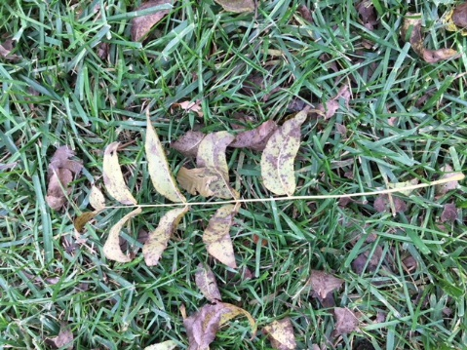

  - Sugar maple (Acer saccharum):

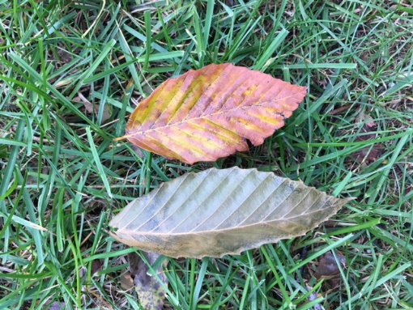
  - American beech (Fagus grandifolia):

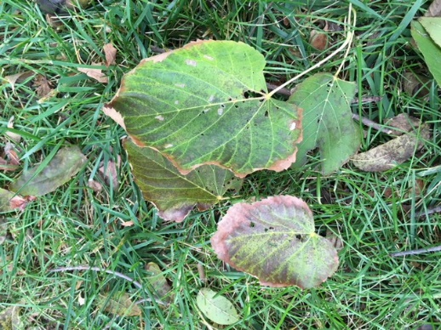
  - American basswood (Tilia americana):

2. Mass the materials within each pile
- Estimate the total N content (in grams) of the samples
  - Multiply the mass of each species’ leaves by the corresponding N content (%) obtained from:
    - Ostrofsky, ML. 1997. Relationship between chemical characteristics of autumn-shed leaves and aquatic processing rates. Journal of North American Benthological Society 16 (4): 750-759
The total N content of my leaf litter trap is ________________ g/trap
=________________g/m²
The average N content across all leaf litter traps is ________________ g/trap
=________________ g/m²
- Estimate the cost of replacing the N content of the leaves with fertilizer should the leaves be removed
  - If the cost of a 12 kg container of 20-0-0 fertilizer (N-P-K; means 20% N by weight) is $23 at Tractor Supply, what is the cost per gram of N? ________________ $/g N
  - Our study area is __________ m²
  - What is the cost to replace N lost if leaves are removed from our study area?
________________________$
  - Our campus area is __________m²
  - What is the cost to replace N lost if leaves are removed from across campus?
________________________$

